Idiot’s Kitchen Shopping List – Butternut Squash & Bacon Risotto

Recipe from idiotskitchen.com – Adapted from the New York Times

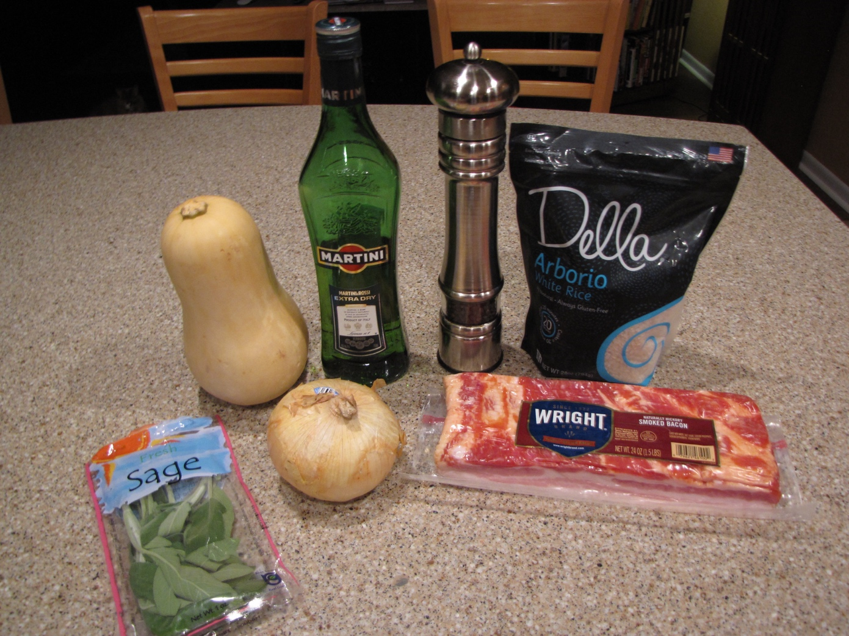

1 butternut squash - 2½ - 3 pounds
1 cup finely chopped onion
2 Tablespoons fresh sage

6 slices thick cut bacon

1½ cups Arborio rice

½ cup white wine (or dry white vermouth)

¾ cup Pecorino Romano cheese, shredded (not pictured)

½ teaspoon rubbed (dried) sage (not pictured)

Salt & Pepper

© Idiot’s Kitchen 2016

